Disclaimer: this article will not endorse any companies, without regard to the amount/length of information provided. The opinions are of this author and him only. He is not being paid, receiving compensation, an employee/representative of said company(ies), or receiving preferred treatment from these companies for this article.

All photos property of the author of this article.

# Transportation

I arrived at Hannover Fairgrounds taking the Stadtbahn. Line U8 runs as usual, but line U18 runs during fair hours.

Hannover MESSE/Laatzen Bahnhof (Deutsche/German for Station accessible by Bahn services) is also available, via the S – Bahn lines S4 and S8, the latter during fair hours. They both go to Hannover Hauptbahnhof (Central Station), and S8 goes to Hannover Flughafen (Airport).

Hannover MESSE/Laatzen Bahnhof sees ICE, IC, and Regio services during fair hours to places such as Frankfurt, Hamburg, Würzburg, Stuttgart, and Munich. For international destinations, ICE services run to Basel SBB and Zurich, both in Switzerland. Otherwise you can take one of the S – Bahn services to Hannover Hauptbahnhof.

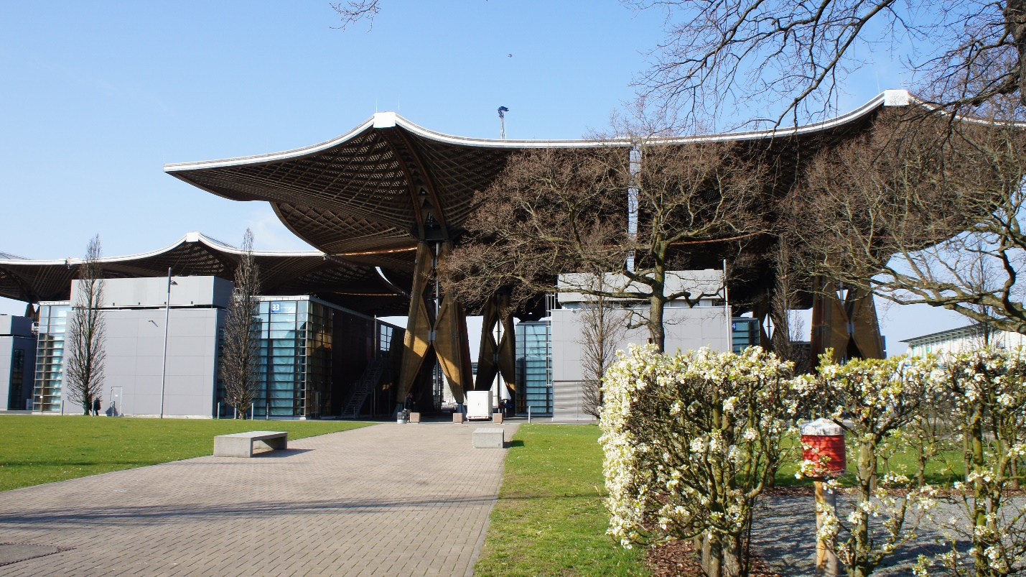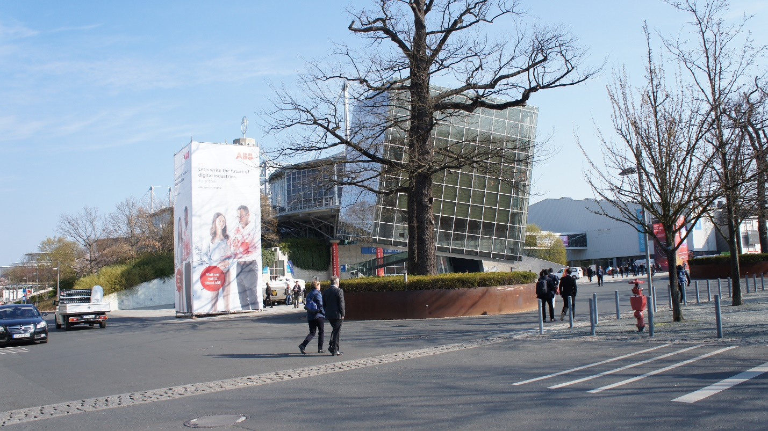

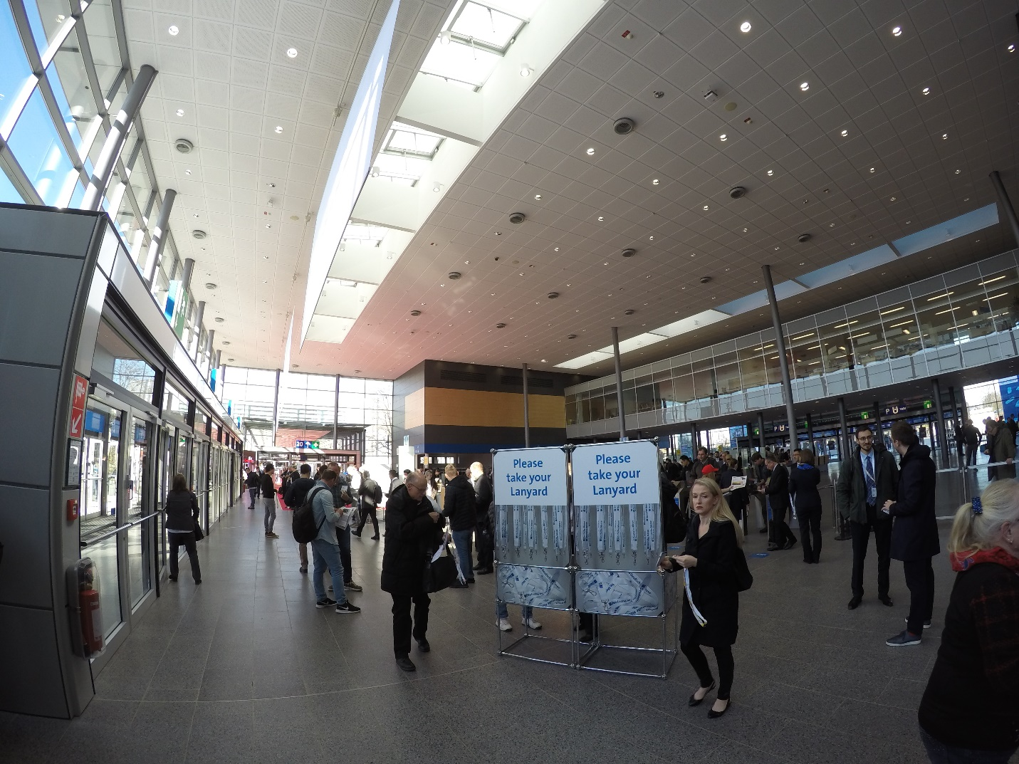

# Industry 4.0 (with a brief on everything before Industry 4.0)

There are four levels of automation and data exchange. Similar to a 4 – point grading scale. They are Industry 1.0, Industry 2.0, Industry 3.0, and Industry 4.0. This section will mainly focus on Industry 4.0.

* *Industry 1.0* basically means something that’s a revolutionary improvement way back (or First Industrial Revolution) … such as the Steam engine. However, it lacks something that makes it cheap. So, we move on to…
* *Industry 2.0*. It means standardization of products. It’s also known as the Second Industrial Revolution, and it basically introduced the idea of the Assembly line. Henry Ford took it to his advantage and created Ford, which are cheap cars (by their standards).
* *Industry 3.0* means more automation in an *Industry 2.0* situation. It is very similar to *Industry 4.0*, but lack something to make it…
* *Industry 4.0* means everything is digital, from the machines to the screen. It includes more complex information, such as Digital Twin and Smart Maintenance. Basically, everything is in The Cloud, a large “place” for storage, computation, analysis, and data management.

In Industry 4.0, there are some more points. They are:

* *Smart Maintenance*, which predicts when something goes wrong so preventative action can be taken. It can shorten downtime for machines, and it reduces costs. For example, if a gear wears out, the issue can be detected before the gear damages the machine and forces a larger maintenance operation.
* *Digital Twin,* which is the replication of the physical machine/robot, as the name suggests. It basically is the digital format of the physical operation, and you could access it by a single screen in front of you (or rather, very easily).
* *Quality Assurance,* the Sensor Inspection, which could be a camera (such as the Cognex Camera), but it’s automated inspection.
* *ERP (Enterprise Resource Planning)*, Resource planning, monetary related, such as Salaries and Taxes.

# Day 1

## Igus

Igus is a company from Köln, Germany. This robot uses suction power to precisely move panels, as shown in this demonstration.

They can operate effectively and can eliminate three employees doing the same job.

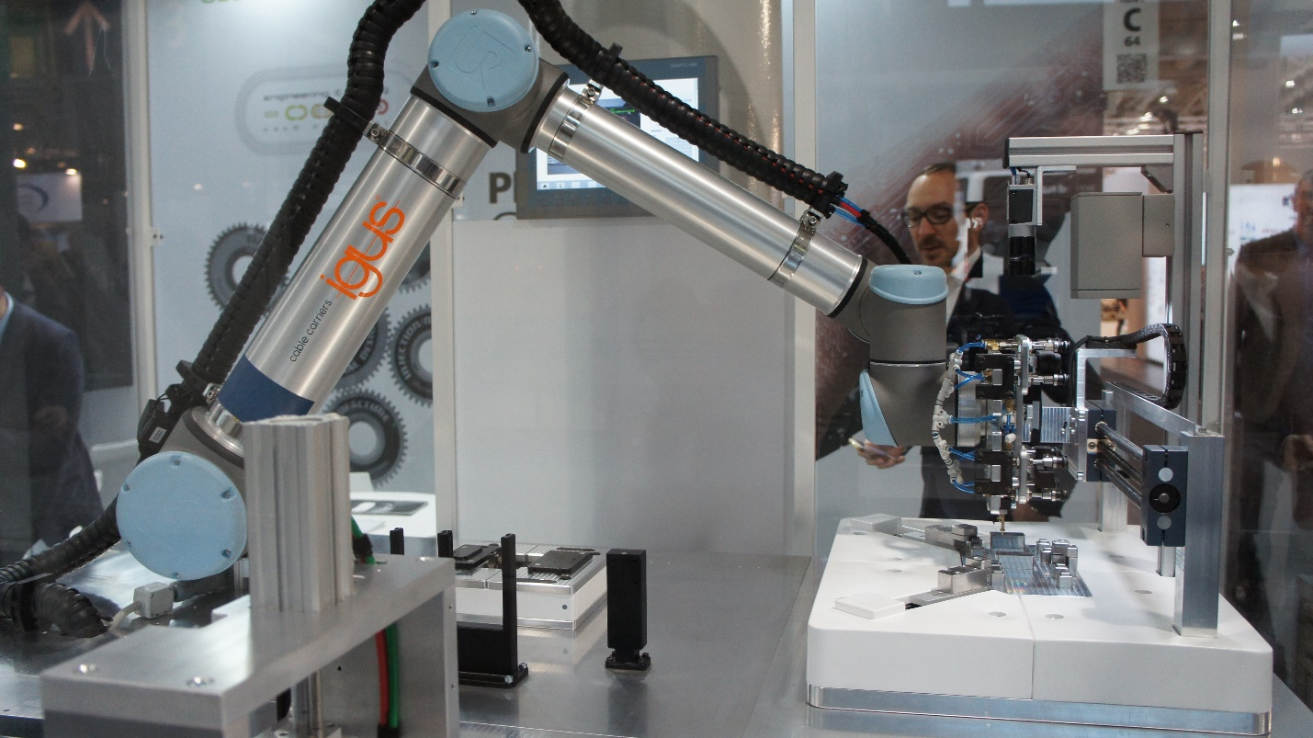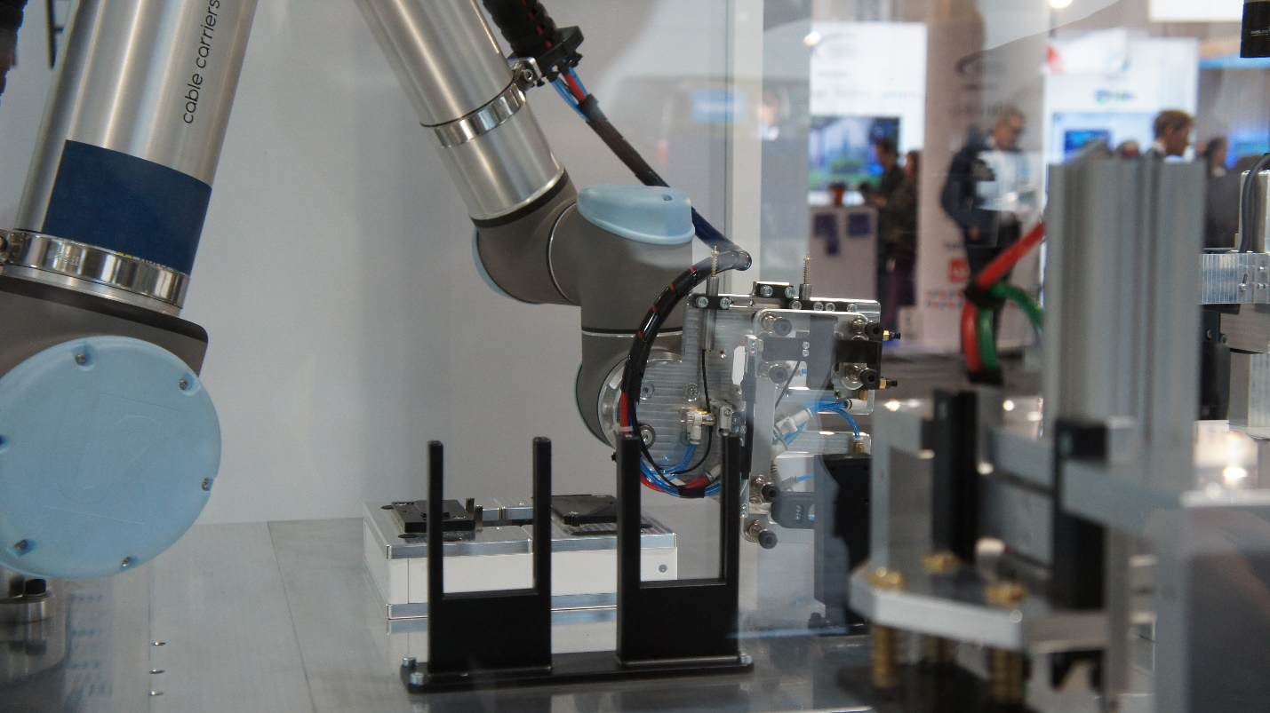

## Festo

Festo is a company also from Germany. They have a large base in Stuttgart.

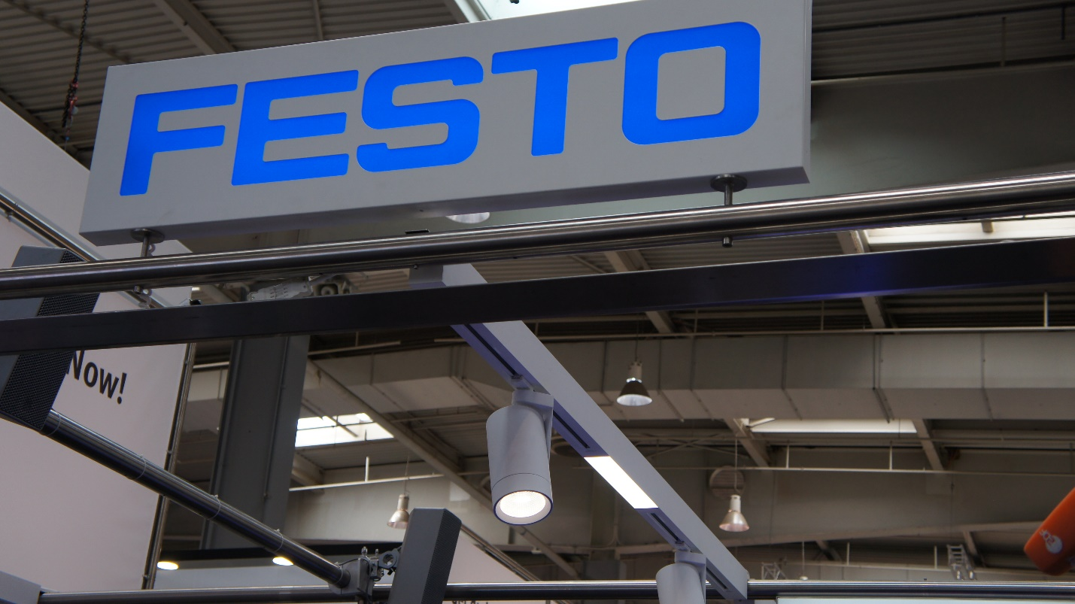

Festo is easily the most popular option when it comes to robots replicating animals and humans, in biotechnology. I liked the hands… 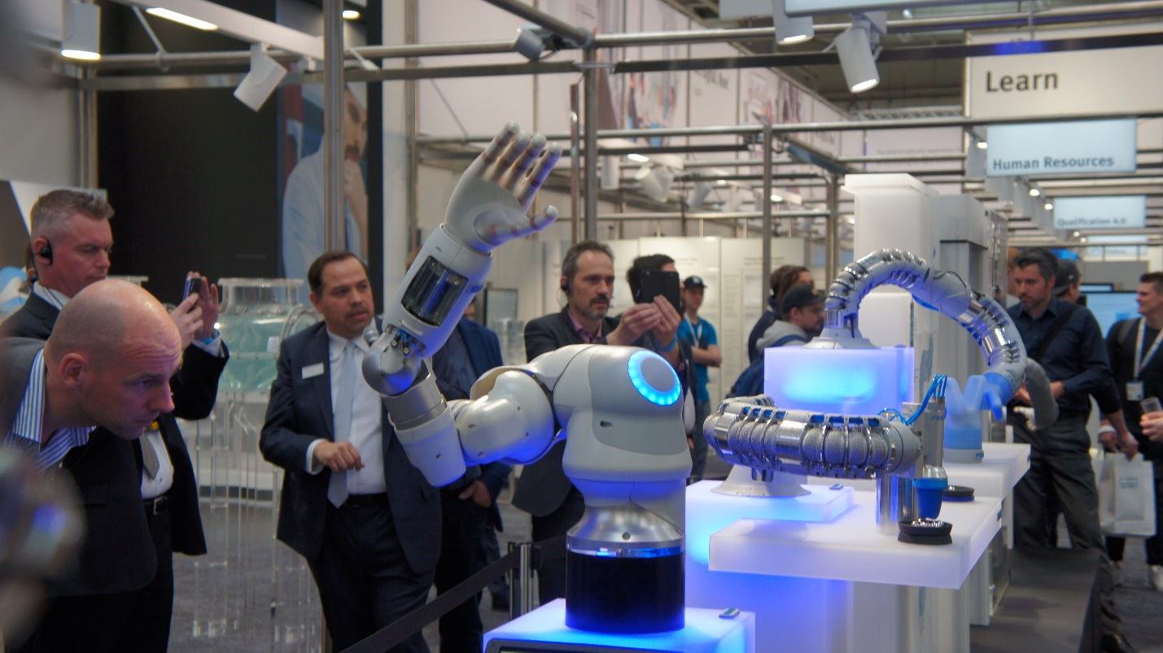

As well as the flexible arm (BionicSoftArm).

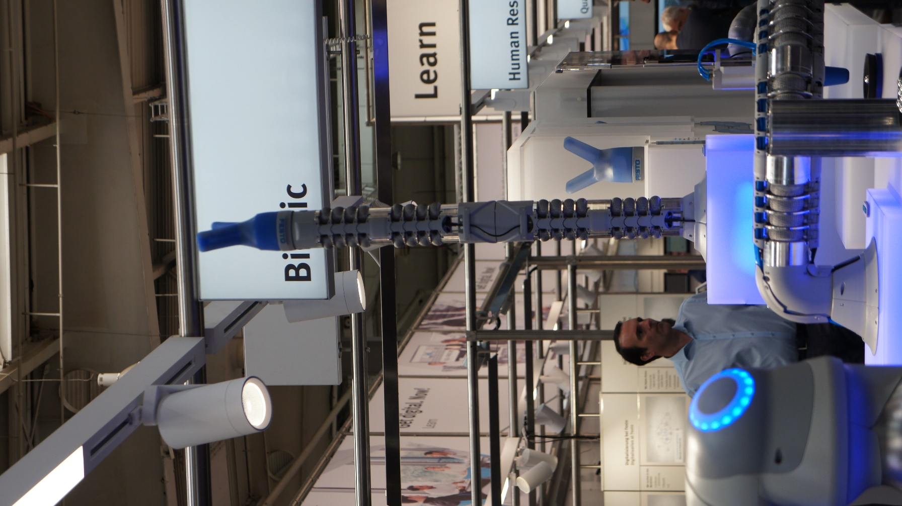

This year they brought the Fish, which can move in water. I believe this is their “Special Demonstration” this year and I am sure they can help complete underwater operations with the bionic fish. They call it BionicFinWave.

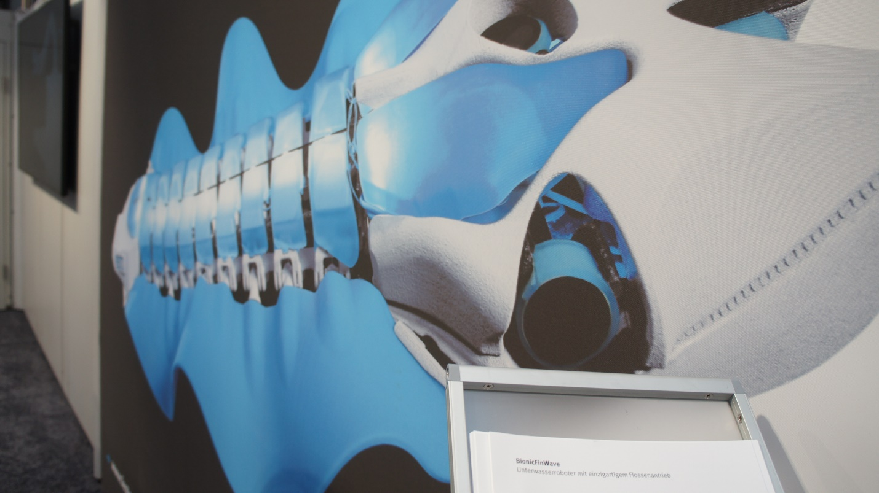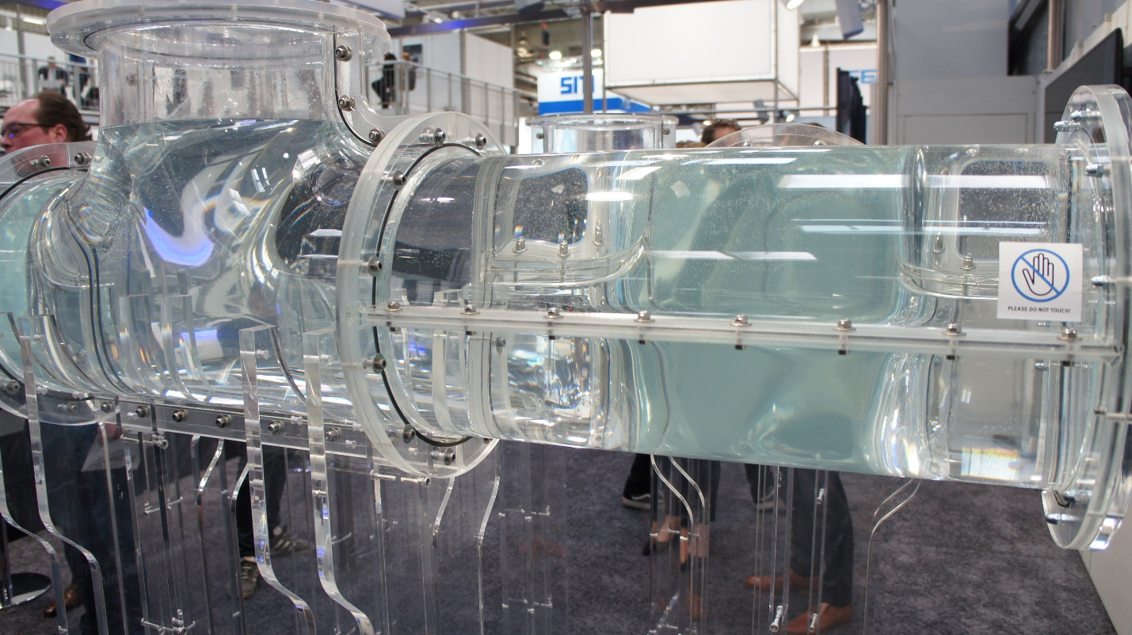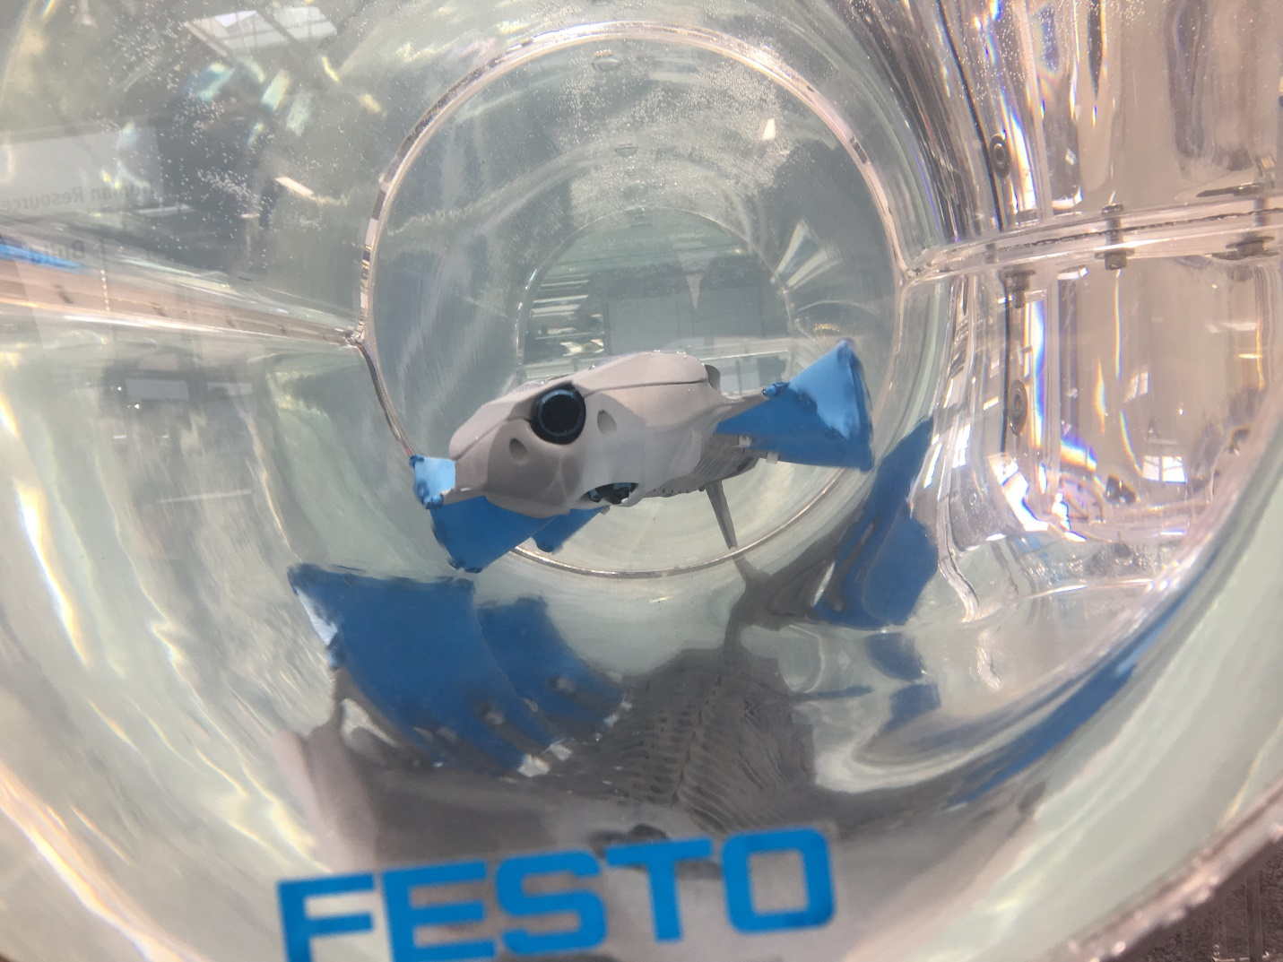

Festo offered to make USB with our names printed on it.

I liked Festo’s Bionic robots. I think they can be used for purposes that can’t be handled by a standard robot and they can lower operating costs.

They also have a miniature assembly line used. It includes assembly of some parts and quality control, which then is transferred to their own Robotino to packaging. Cool, I’ve always wanted to see Robotino.

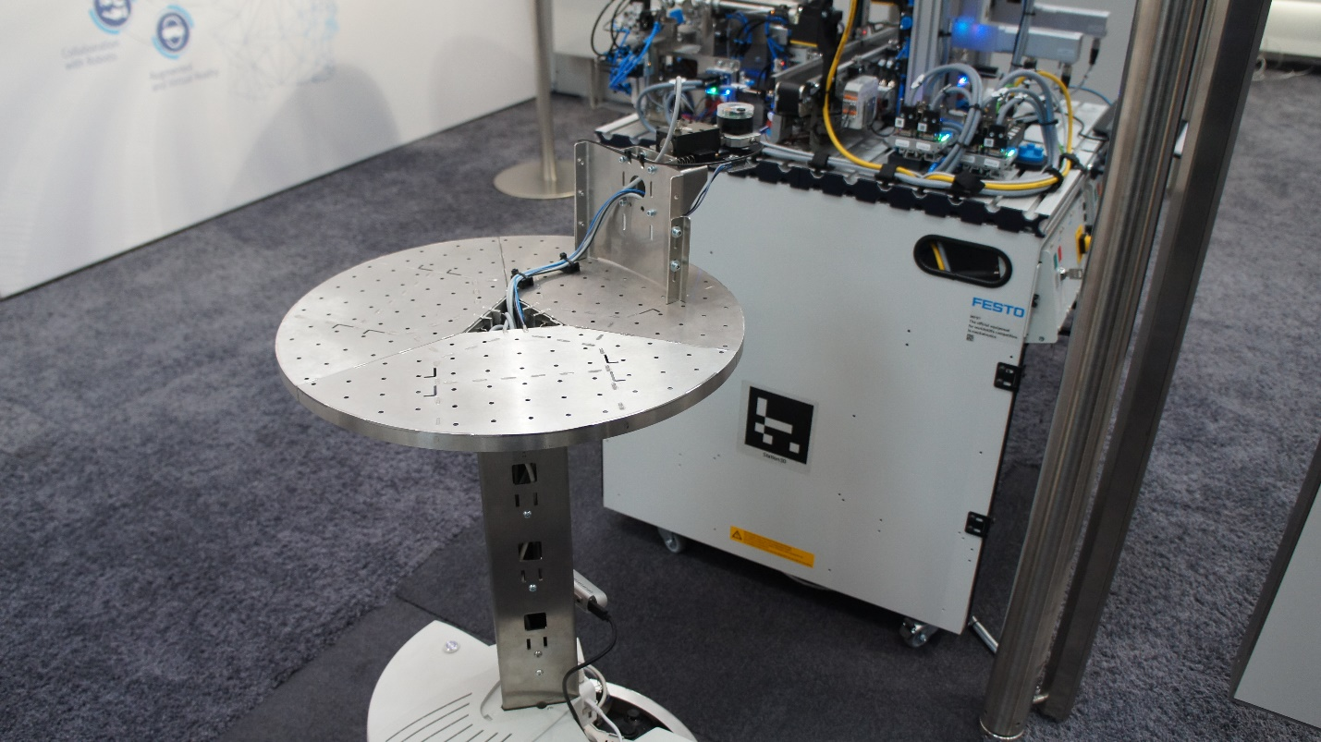

This eliminates five workers from the assembly line.

It works for corporations because not only does this decrease the number of employees required, it reduces the operating cost. And if you’re having trouble looking for someone to hire, you may well be done with it with these robots… and Robotino.

The entire process is called Automated Guiding Vehicle (AGV).

## Kawasaki Heavy Industries

Kawasaki, a company based in Japan, is known for Automobiles. They also procure robots for those automobiles. I particularly liked the Lightsaber demonstration.

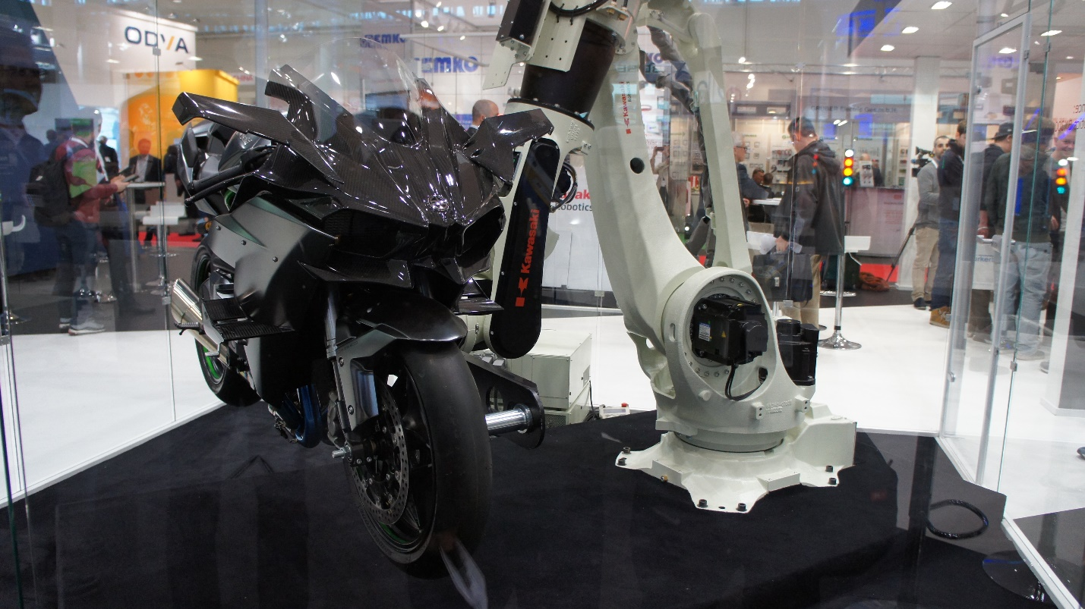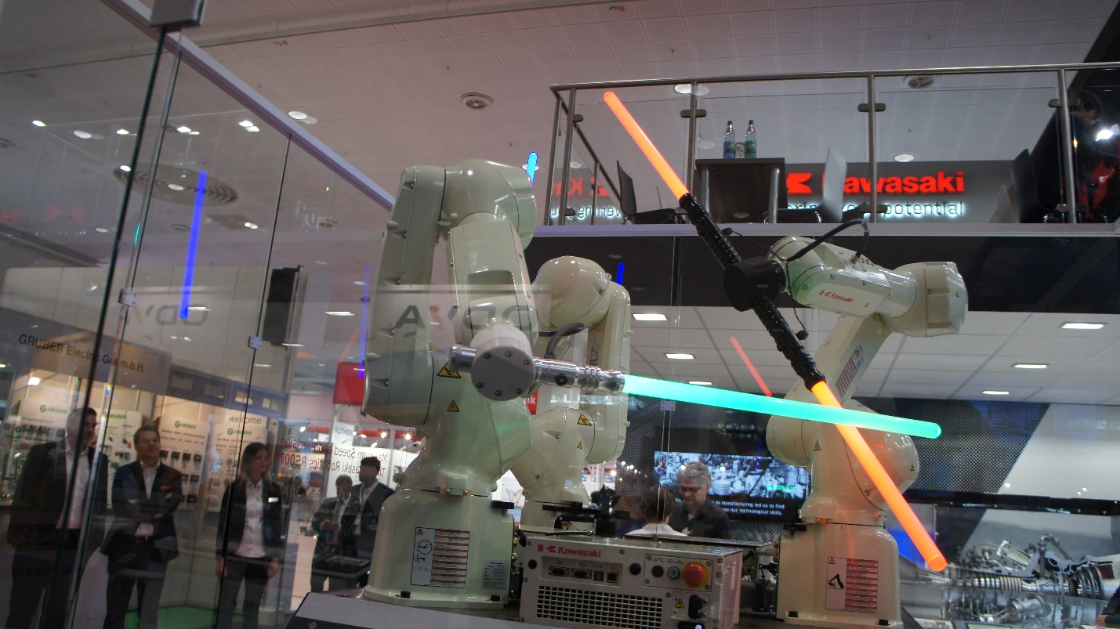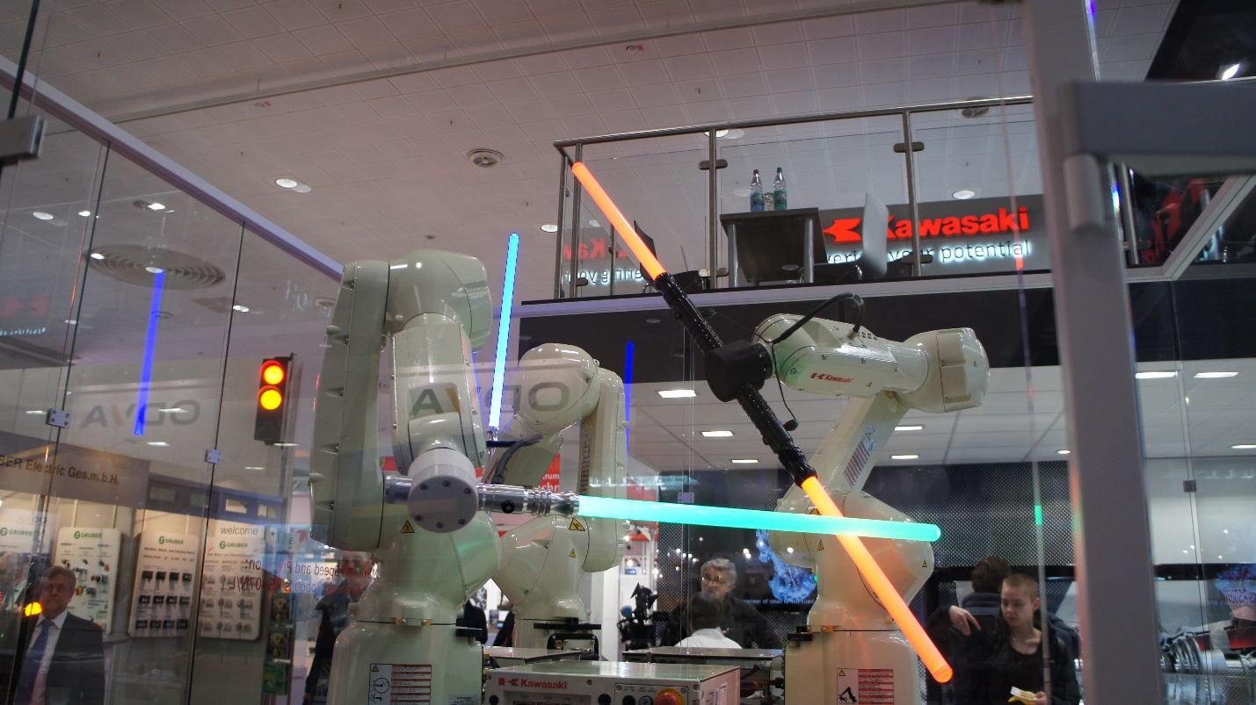

## Nokia

Nokia is a company based in Finland.

This year, they brought “Go Allwhere,” which is their moving robot (like Festo’s Robotino). I found it nice to get something from Point A to Point B without a human. It eliminates one person from the line.

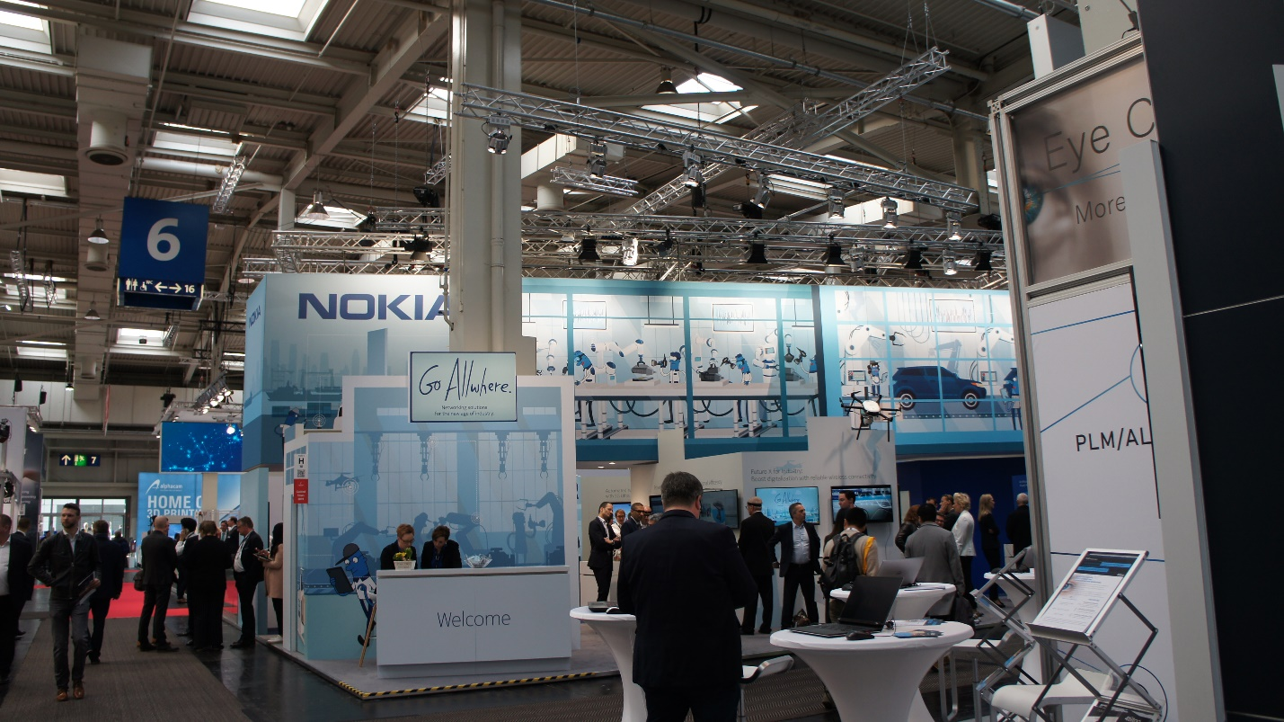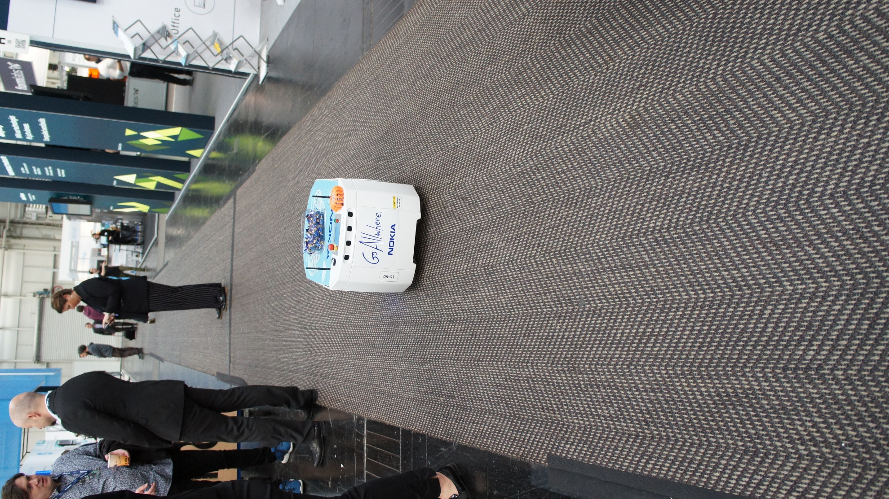 Of course, I enjoyed a piece of candy “Go Allwhere” offered me. Greatly appreciate it!

# Day 2

## Fanuc

Fanuc is headquartered in Japan, but most of their company is based in the United States of America. Interestingly their name is an acronym for **F**uji **A**utomatic **Nu**merical **C**ontrol. They have a large exhibit set up and a lot of mechanical machines. I may (or may not) have taken one of their pens they were offering.

First, I played against their robot in a classic game. Their robot beat me… very badly.

Next I looked at their long line of machine used for automobile manufacturing. They are strong enough to lift an automobile.

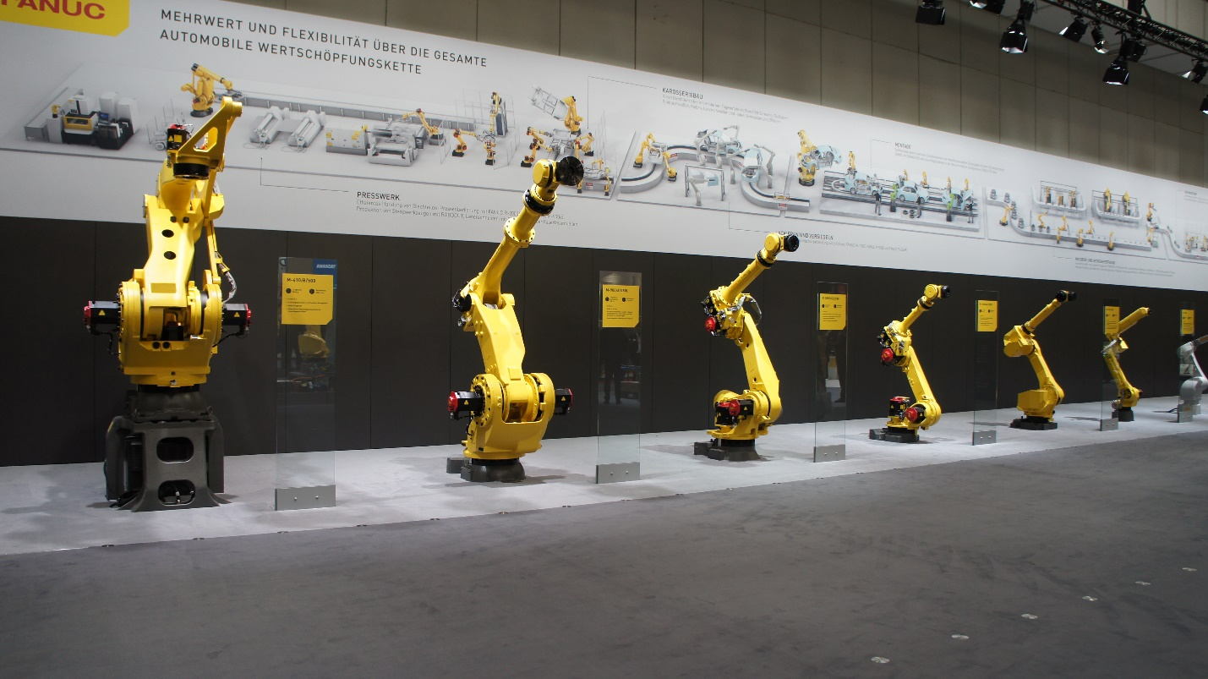

I also looked at their robots used for assistance in door manufacturing. 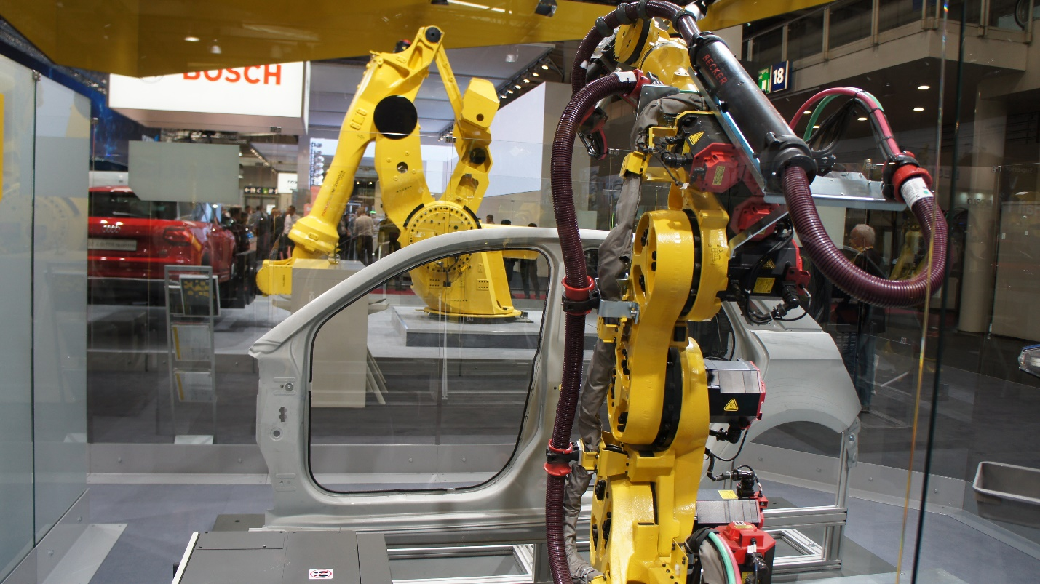

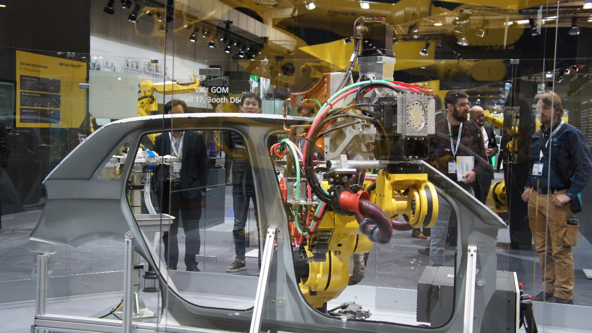

This robot is assisting in something in the middle I canot identify. (maybe something to do with a human?)

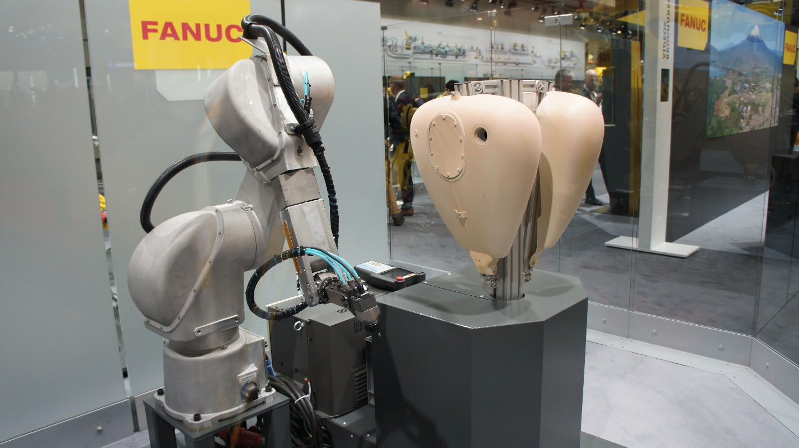

Here are one of their robots assisting in lifting and moving an automobile!

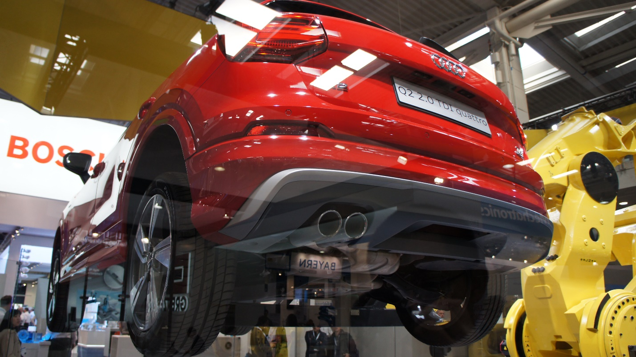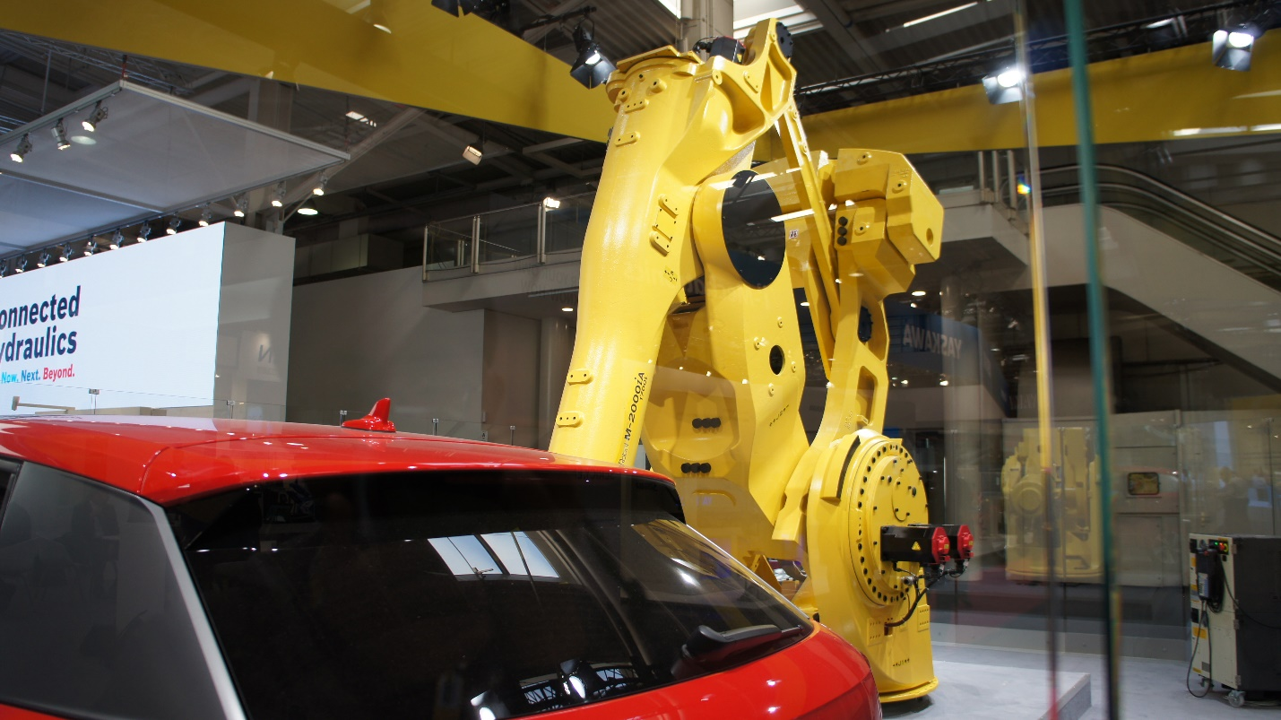

## Yamaha

I also went to see Yamaha’s operation. They’re based in Japan.

These can assemble and disassemble a product. They use a laser camera to measure an object and assemble something correctly.

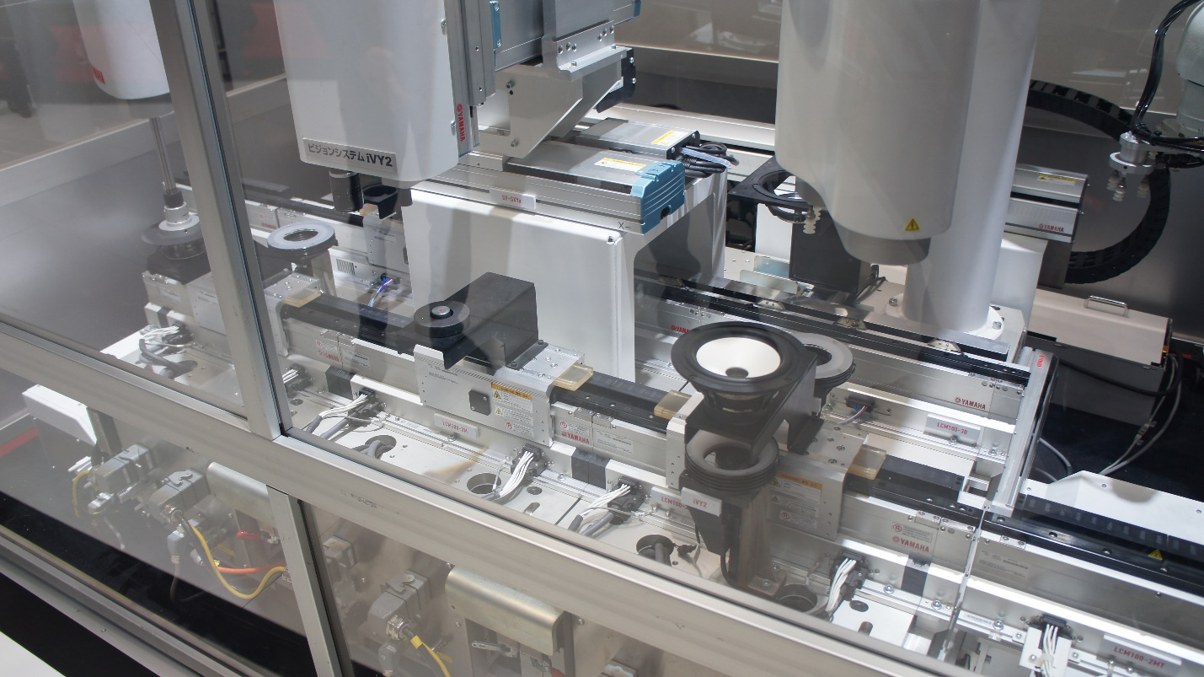

## Yaskawa

They’re Japanese based, and they also have a few robots on offer. Admittedly I was getting blaise about it and less disinterested in this brand.

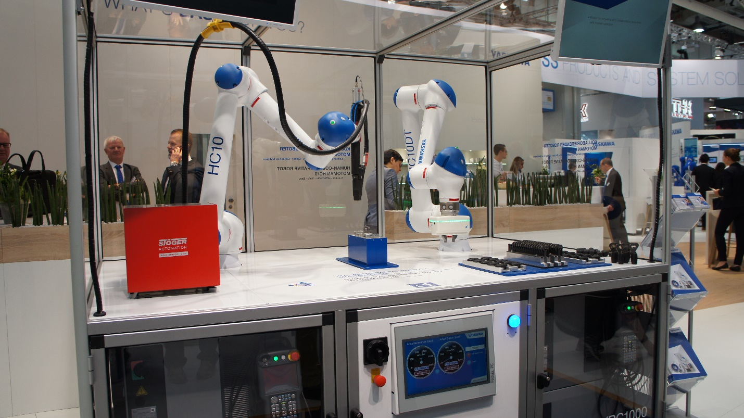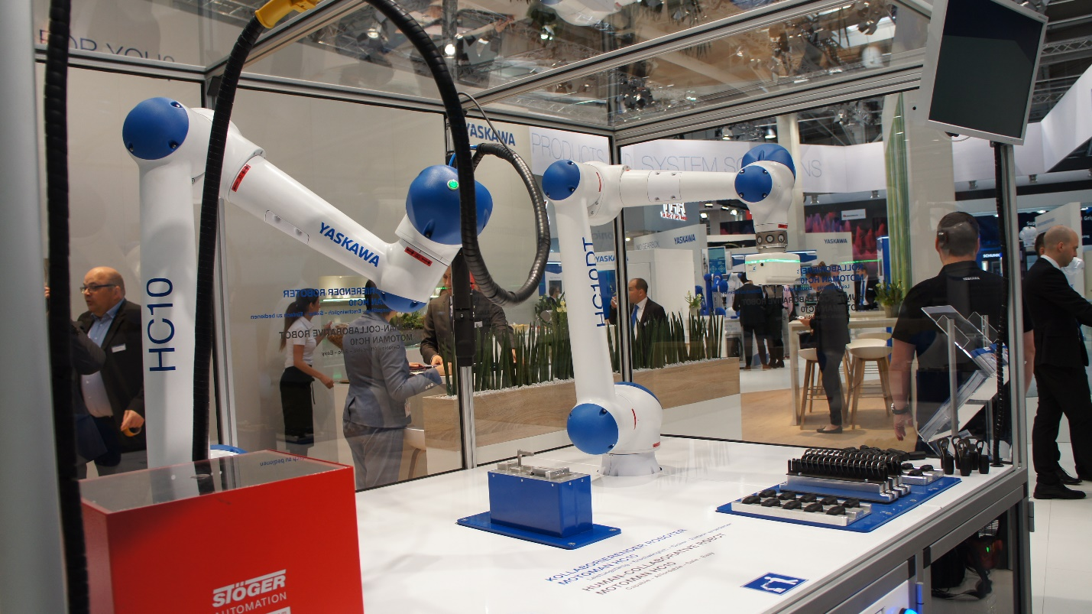

## Schunk

Schunk is a company headquartered in Germany with a base in both Germany and the United States. They created a really good robot for vaccines in hospitals and clinics.

This robot safely adds medicine to a syringe, which is used by the nurse and then disposed of properly. It cannot mix it up with anything else. 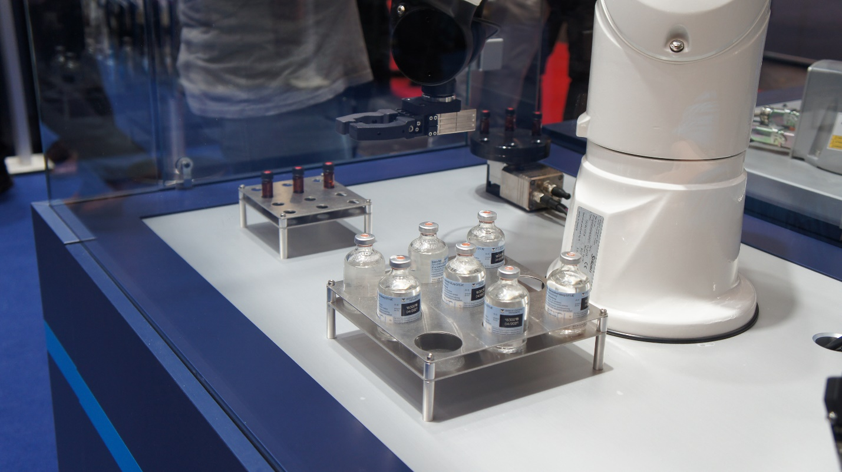

Gears are also assembled.

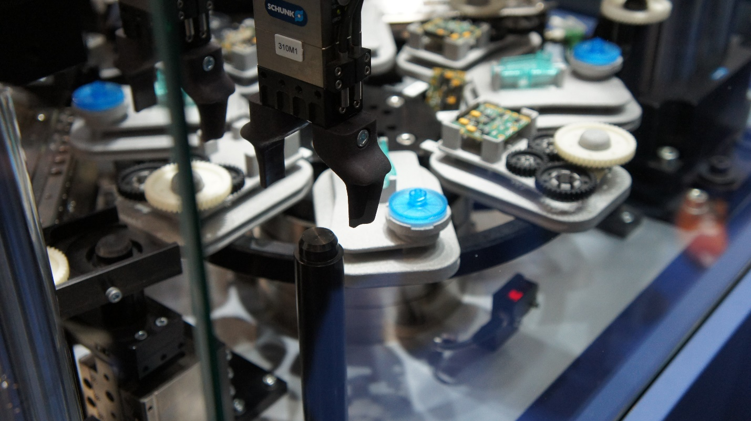

They also have robots for very precise use, where something small is assembled, disassembled, or used in some other way.

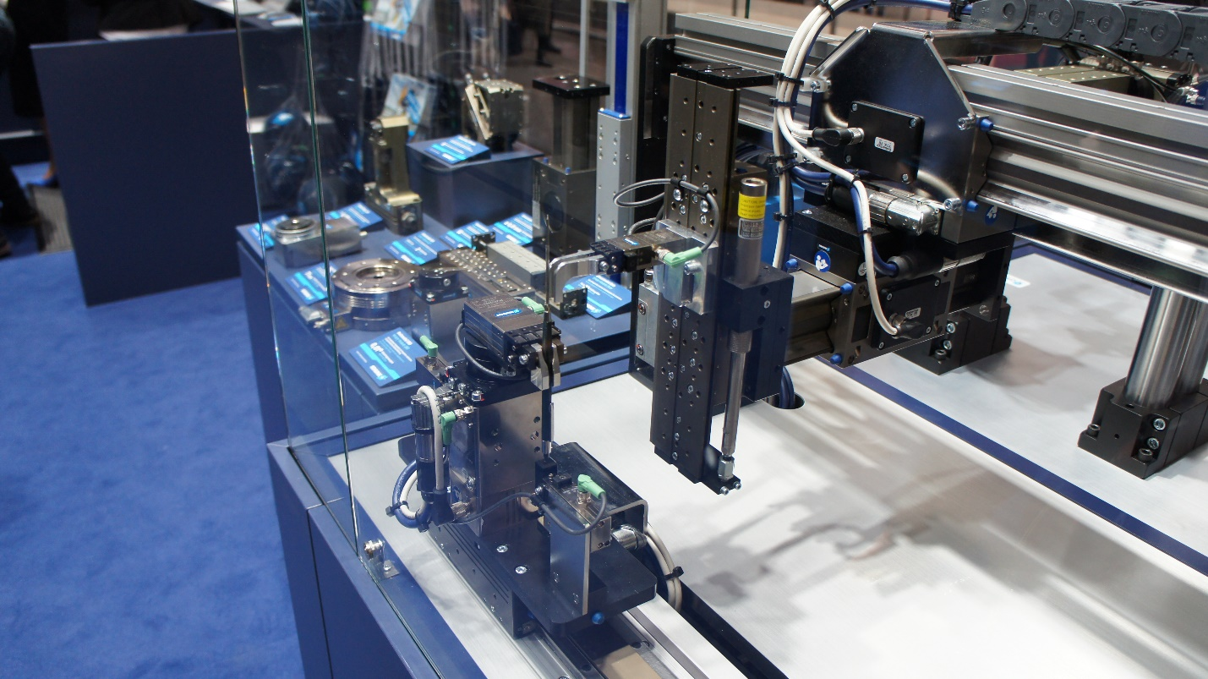

## Universal Robots

UR is based in Denmark. They have a very good show of using their robotic screens, I liked it.

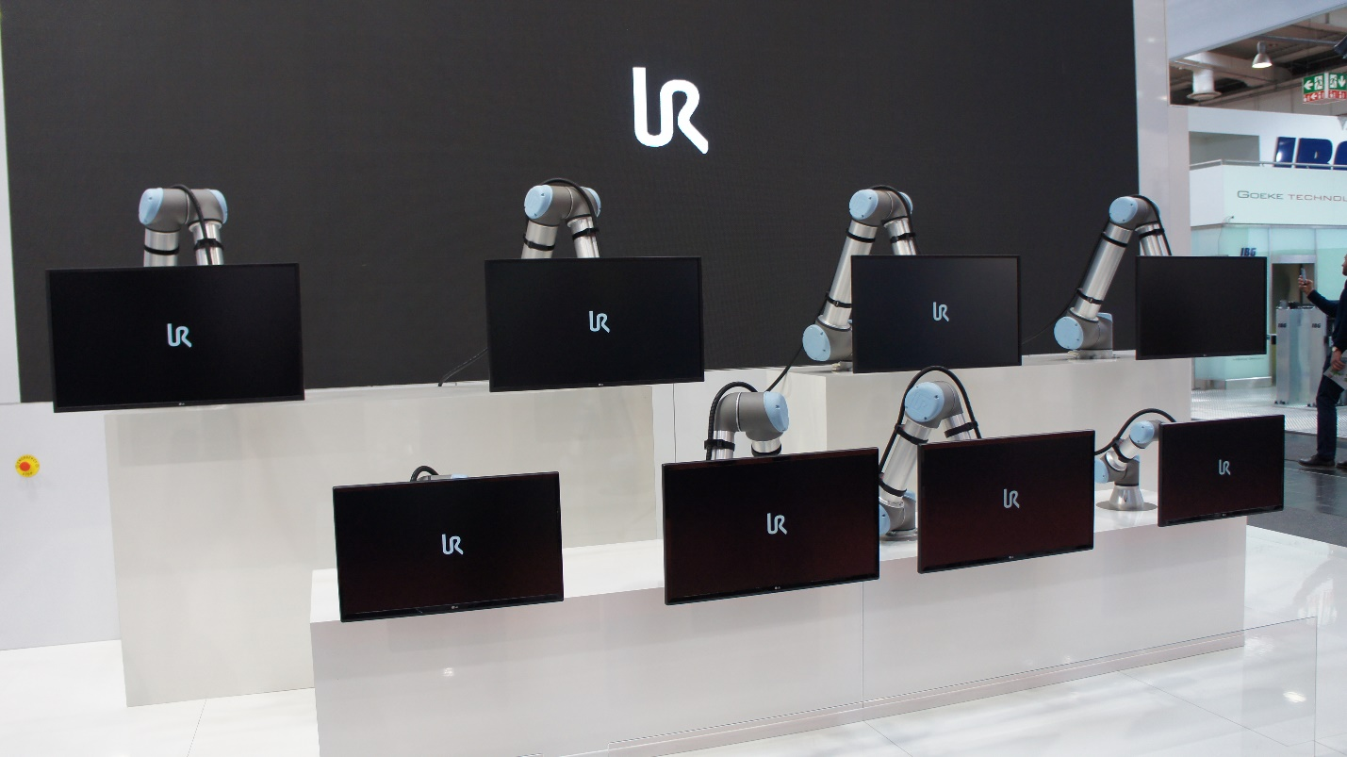

They showed their flashlight making and offered me a flashlight to take home. This assembly line can eliminate three employees given the robots prepare and assemble.

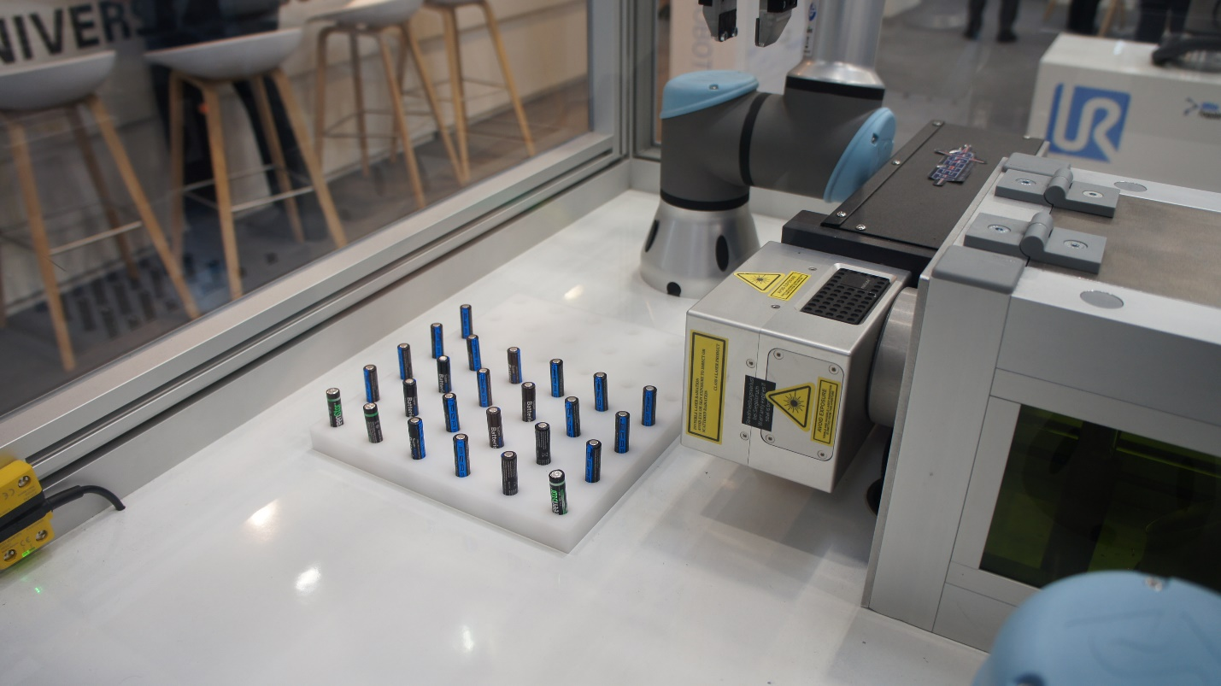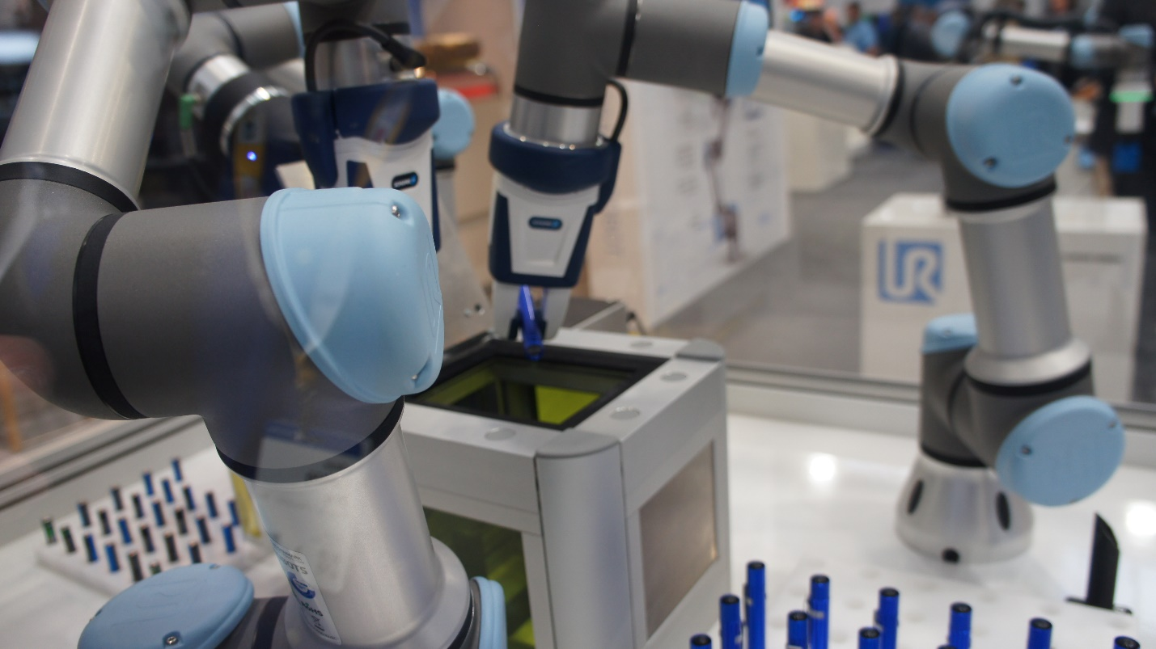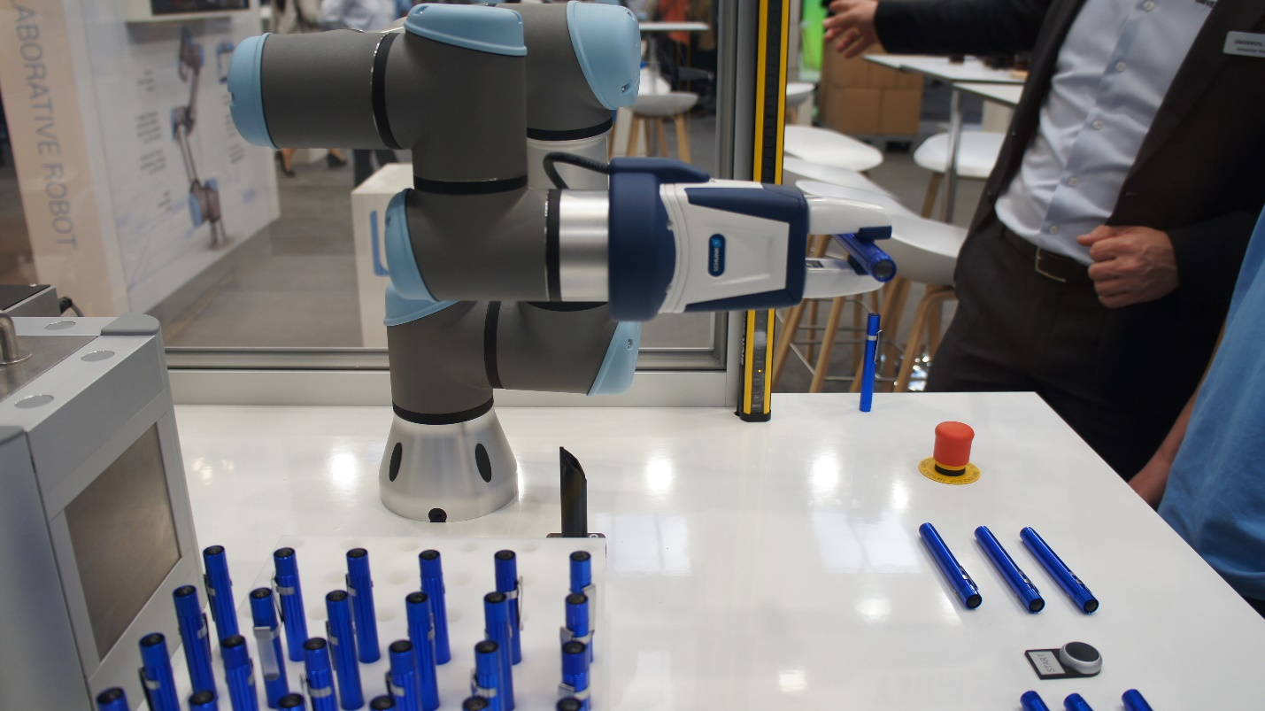

# Overall Thoughts

I liked this year’s show. My favorite would be Festo, but most other exhibitors had very decent shows. I liked that they have people explaining in more than one language.

I am sure a lot of corporations will have manufacturing and technology much easier after purchasing a product. I am sure they can cut costs in the purchase of these, operationally.

The safety offerings were in different halls. Unfortunately, I was unable to visit these exhibitors as I only had a day and it was not enough apparently!